 | Autumn 1 | Autumn 2 | Spring 1 | Spring 2 | Summer 1 | Summer 2
Topic title | Indian Spice  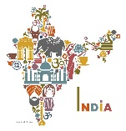 | 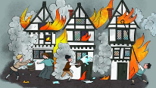  Fire! Fire! | Frozen Planet!  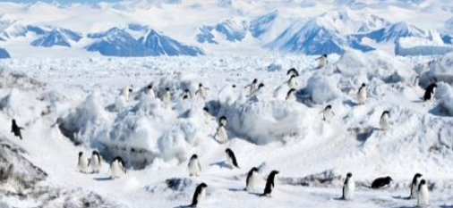 | 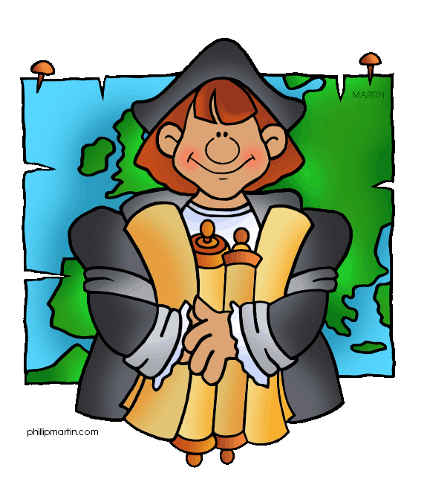  Ahoy there! | Oh I do like to be beside the Seaside!  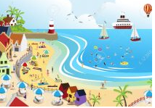 | Wonder Women!
Wow starter  Visitor/trip | Food tasting. | Baking bread  Bankfield Museum | Create a Winter scene- after watching parts of Frozen Planet.  Yorkshire Wildlife Park | Message in a bottle- follow clues to find different facts.  Pirate workshop in school. | Make own lighthouse.  Trip to Formby | Learn basic first-aid (visit from nurse/paramedic)  Bankfield Museum. Visit from a soldier/doctor.
Reading into writing process | The Fantastic Mr Fox  Fiction: narrative in Mr Fox’s perspective, letter, poetry, descriptive sentences.  Non-fiction: non-chronological report, fact file, news report | Vlad and the Great Fire of London  Non-fiction: Instructions for baking bread  Fiction: descriptive writing, diary entries  Poetry: performing and writing descriptive poems  The Gingerbread Man  Fiction: imaginative story writing  The Polar Express  Fiction: descriptive writing | The Journey Home  Fiction: character descriptions, story writing  The Rainbow Bear  Non-fiction: information text  Fiction: setting descriptions  The Way Home For Wolf | The Owl and the Pussycat  Fiction: letter  Poetry: performing poems.  The Tin Forest  House Held Up By Trees  Fiction: Narrative- 3 part story.  Non-fiction: descriptive information text, write a newspaper report based on the story | The Dragon Machine  Non-fiction: non-chronological report, letter  Fiction: descriptive writing, story writing  Queen Victoria’s Bathing Machine  Fiction: setting description, short story  The Day War Came  (Refugee Week text) | Rosie Revere, Engineer  Non-fiction: explanation text, report, advert / leaflet  Daisy Saves the Day  Little Evie and the Wild Wood
Cross-curricular writing | Place description.  Postcards from India. | Evaluation of Tudor house.  Description of London then and now.  Bonfire night. | Postcards form a cold region.  Non-chronological reports. | Non-chronological report about Columbus.  Letter writing. | Postcards and letters.  Recount of trip.  Fact-file about Victorian seaside’s. | Flipbook fact file about Florence Nightingale/Mary Seacole.
Class book | The Giraffe, the Pelly and Me by Roald Dahl. | The Enchanted Wood by Enid Blyton | The Last Polar Bears by Harry Horse | Hodgeheg by Dink King-Smith. | Flat Stanley by Jeff Brown | Hetty Feather by Jacqueline Wilson
Maths | Place Value.  Addition & Subtraction. | Money.  Multiplication.  Consolidation. | Division.  Statistics.  Shape | Position & direction.  Efficient problem solving methods. | Time.  Mass, Capacity & Measure. | Fractions.  Length & Height.  Consolidation.
Cross-curricular maths | Patterns linked to art. | Telling the time- linked to ordering events of the fire. | Temperature. | Position & direction. | Telling the time. | Statistics
Science | Animals including humans (a)  Healthy Me  Find out about and describe the basic needs of animals, including humans, for survival (water, food and air).  Describe the importance for humans to be hygienic.  Notice that animals, including humans, have offspring which grow into adults. | Animals including humans  Little Masterchefs  Describe the importance for humans of exercise, eating the right amounts of different types of food, & hygiene.  - Design, prepare and cook healthy pizzas  - Life cycles – reproduction and growth  - Human stages of development | Use of everyday material  Materials Monster  Identify & compare the suitability of a variety of everyday materials, including wood, metal, plastic, glass, brick, rock, paper & cardboard for particular uses.  Squash Bend Twist and Stretch  Find out how the shapes of solid objects made from some materials can be changed by squashing, bending, twisting and stretching. | Plants  Young Gardeners  To observe and describe how seeds and bulbs grow into mature plants. To find out and describe how plants need water, light and a suitable temperature to grow and stay healthy | Living things & their habitats  (a)  Our Local Environment  Explore & compare the differences between things that are living, dead, and things that have never been alive.  Identify that most living things live in habitats to which they are suited & describe how different habitats provide for the basic needs of different kinds of animals & plants. | Living things & their habitats (b)  Our Local Environment  Identify & name a variety of animals in their habitats, including microhabitats.  Describe how animals obtain their food from plants and other animals, using the idea of a simple food chain, and identify and name different sources of food.
Geography | Place knowledge  Understand similarities & differences through studying human & physical geography of our local area and a small area in India.  Geographical skills & fieldwork  Use maps, atlases and globes to identify the UK and India. | Locational knowledge  Locate London and know that it’s the capital city of England & what its surrounding sea is. Revise the four countries of the UK and identify their capitals.  Geographical skills & fieldwork  Use maps, atlases and globes to identify the UK and its countries.  Use aerial photographs of London to identify physical and human features and landmarks.  Devise a simple map of how London should be rebuilt – use basic symbols in a key. | Human & physical geography  Identify the location of cold areas of the world in relation to the equator & the North & South Poles.  Discuss different times for seasons around the world.  Art link – 3d work  Saltdough models of Antarctica and Arctic | Locational knowledge  Name & locate the seven continents & five oceans- link them to Columbus’ voyage.  Human & physical geography  Use geographical vocabulary to refer to: forest, hill, mountain, sea, river and ocean by exploring a habitat (Science) found on each continent.  Geographical skills & fieldwork  Use maps, atlases and globes to locate oceans & continents. | Human & physical geography  Use geographical vocabulary to refer to: beach, cliff, coast, sea, ocean and port/harbour.  Geographical skills & fieldwork  Use simple compass directions and locational and directional language to describe the location of features and routes on a map.  Devise a simple map (of a seaside) and construct simple symbols for this map- showing the above language. | Geographical skills & fieldwork  Use maps to show where Wonder Women of the world have come from.
History |  | Chronology and comparing different periods  Timeline of events from the Great Fire.  Comparing life in London now and then.  Sources of evidence  Paintings, drawing, diary entries, stories, non-fiction texts.  Events beyond living memory that are significant nationally  Great Fire of London 1666 | Chronology and comparing different periods  Understand when Scott the explorer completed his expeditions. Compare to other historical events studied (before, after).  Sources of evidence  Photos, news articles, videos.  Significant individuals in the past who have contributed to national & international achievements  Scott the Explorer. | Chronology and comparing different periods  Timeline of Christopher Columbus’ life.  Sources of evidence  Ask and answer questions about his voyages.  Significant individuals in the past who have contributed to national & international achievements  Christopher Columbus | Chronology and comparing different periods  Similarities and differences between seasides from the past and present  Sources of evidence  Analysing sources of evidence – what do they tell us about seasides from the past?  Changes within living memory (aspect of change in national life)  The Victorian Seaside, seasides from the past. Revise ‘who was Queen in the Victorian times?’ | Chronology and comparing different periods  Compare when women being studied lived and difference in life then and now.  Significant individuals in the past who have contributed to national & international achievements  Florence Nightingale, Edith Cavell, Mary Seacole  Rosa Parks, Emily Davison  Helen Keller, Grace Darling
Art | Drawing and painting:  Rangoli patterns  Collage:  Rangoli patterns (symmetry) | Painting:  Great Fire of London silhouette artwork | Printing:  Kandinsky – repeating pattern.  Fruit and vegetable prints – foam board printing  Collage:  Archimbaldo - fruit and veg portraits | 3D work  Pirate ship sculptures / junk modelling | Textiles:  Revisit Gunta Stolzl – weaving / sewing | Photography:  David Hockney ‘Joiners’ – creating own portraits.  Drawing and painting:  Using paint to create a portrait of a ‘Wonder Women’.
D & T |  | Cooking:  Making bread | Cooking and nutrition:  Plan, design & make a healthy fruit salad (Science link) | Moving mechaniams  Seascape pirate ship scene? | Textiles:  Design and make own hand puppet linked to Punch & Judy.
Computing | Coding and e-safety | Spreadsheets, questioning and e-safety | Effective searching and e-safety | Creating pictures and e-safety | Making music and e-safety | Presenting ideas and e-safety
P.E | Y2 P.E scheme | Y2 P.E scheme | Y2 P.E scheme | Y2 P.E scheme | Y2 P.E scheme | Y2 P.E scheme
Music | Listening and appraising  Singing and improvising  Singing and performing | Singing, playing instruments and performing | Singing and improvising  Singing and performing composition | Singing, playing instruments, improvising and performing | Singing, playing instruments, improvising and performing | Prepare for a performance of songs and activities from the  year.

ART – drawing, painting, printing, 3d work, collage, textiles, evaluation

