 | Autumn 1 | Autumn 2 | Spring 1 | Spring 2 | Summer 1 | Summer 2
Topic title | Active planet  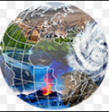 | Let’s go to China!  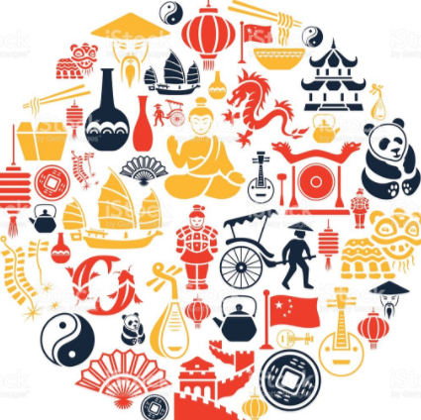 | Yabadabadoo  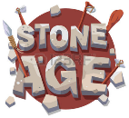 | We built this city  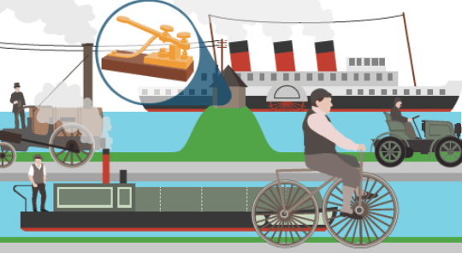 | Our Ocean Planet  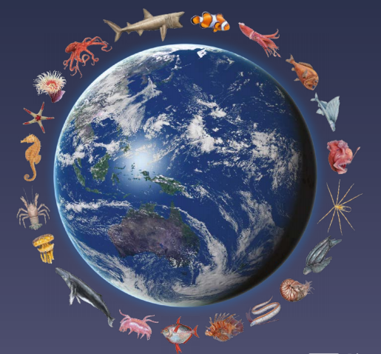 | Walk like an Egyptian  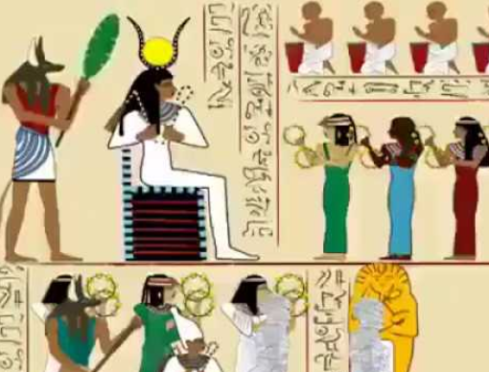
Visitor/trip | Prime VR | Tasting Chinese food | Trip to Murton Park | Trip to Halifax Industrial Museum | Trip to aquarium and the port in Hull
Reading into writing process | Escape from Pompeii  Poetry: Pompeii/volcano poems  Fiction: historical story, dialogue, setting description.  Non-fiction: news article  Pebble in my Pocket  Fiction: diary entry, setting description, own journey of a pebble story  Non-fiction: explanation texts  Poetry: using similes | The Firework Makers Daughter  Poetry: similes.  Fiction: Diary entry, setting description, missing scene/chapter  Non-fiction: persuasive letter, instructions, non-chronological report | Stone Age Boy  Fiction: writing a sequel: ‘The Stone Age Boy returns…’  Non-fiction: persuasive text (looking at leaflets and creating own Stone Age camp)  The First Drawing  Fiction: character description, narrative, diary writing | Mary Poppins  Fiction: a series of diary entries from the perspective of Jane, Michael and other characters they meet along the way  An extended narrative ‘the missing chapter’  Non-fiction: a persuasive letter from Jane and Michael Banks to Mary Poppins  Poetry - shape poems based on Mary Poppins | The Sandman and the Sea Turtles by Michael Morpurgo  Non-fiction: non-chronological report, letter writing  Fiction: setting and character descriptions, missing chapter, use of dialogue, diary writing  Poetry: narrative poetry  A Story Like The Wind Gill Lewis & Jo Weaver  Memoirs | Cinderella of the Nile  Fiction- diary entry, character description, advert, own version of a traditional tale  Non-fiction-  Short news report  The Story of Tutankhamun  by Patricia Cleveland-Peck  Fiction: diary entry  Non-fiction: biography, non-chronological reports, instructions, newspaper reports and posters
Cross-curricular writing | Postcards from a volcano  Explanation writing  Fact files | A tourist guide for China.  Fact file.  A day in the life of… | Day in the life of a…  Explanation text- healthy eating. | Letter writing.  Information leaflet- industrial revolution. | Recount of school trip.  Explanation text about ports and their purpose. | Non-chronological reports Pharaohs.  Flip books- Canopic jars.
Guided reading book | I survived the destruction of Pompeii, Ad 79 | The Firework Makers Daughter by Philip Pullman. | The Iron Man by Ted Hughes. | Oliver Twist retold by Gill Tavner. | A Story Like The Wind Gill Lewis & Jo Weaver | A Necklace Of Raindrops by Joan Aiken
Class book | George’s Marvellous Medicine | The Fox and the Ghost King | The Iron Man by Ted Hughes. | Street Child (Essential Modern Classics) | The Train to Impossible Places by P. G. Bell | Secrets of a Sun King by  Emma Carroll
Maths | Place Value (numbers to 1,000)  Addition & Subtraction | Multiplication & Division  Money  Statistics | Addition & Subtraction  Multiplication & Division  Consolidation | Length & Perimeter  Fractions  Consolidation | Properties of Shapes  Mass & Capacity  Consolidation | Properties of Shapes  Mass & Capacity  Consolidation
Cross-curricular maths | Ordering numbers from the Richter scale. | Time for a ‘day in the life of… | Looking at how they counted in the Stone Age. | Measurement and data. | Measuring- shadows  Time. | Measuring- shadows  Time.
Science | Rocks  Compare and group rocks.  Describe fossils in simple terms.  Recognise how soil is formed. | Forces & Magnets  Compare how things move on different surfaces.  Notice that some forces need contact between 2 objects.  Observe how magnets attract or repel each other & attract some materials & not others.  Compare & group together everyday materials based on magnetism.  Describe magnets as having two poles.  Predict whether two magnets will attract or repel each other. | Light and shadows  Recognise that we need light to see things.  Notice that light is reflected from surfaces.  Recognise that light can be dangerous & how to protect our eyes.  Know how shadows are formed.  Find patterns in the way that the size of shadows change | Science in action  Make systematic and careful observations and, where appropriate, take accurate measurements using standard units and a range of equipment.  Gather, record, classify and present data to help answer questions.  Ask relevant questions and use different types of scientific enquiry to answer them.  . | Food and our bodes: animals including humans  Identify that all animals need the right types of nutrition.  Know that animals get nutrition for what they eat.  Identify that humans & some other animals have skeletons & muscles for support, protection & movement. | Science in action  Make systematic and careful observations and, where appropriate, take accurate measurements using standard units and a range of equipment.  Gather, record, classify and present data to help answer questions.  Ask relevant questions and use different types of scientific enquiry to answer them.
Geography | Human & physical geography  Describe and understand key aspects of volcanoes and earthquakes.  Use maps and globes to locate countries which have earthquakes and volcanoes.  Locational knowledge  Locate some of the world’s countries, focusing on locating physical characteristics (volcanoes).  Geographical skills & fieldwork  Use maps and atlases locate countries and regions, describe features studied | Place knowledge and Human & physical geography  Similarities and differences between China and the UK.  Describe and understand key aspects of human geography, including land use.  Describe and understand key aspects of physical geography, including: climate zones, rivers, mountains, locating these in China  Identify human and physical features in a country.  Geographical skills & fieldwork  Use maps, atlases and compute mapping to locate countries and regions, describe features studied | Locational knowledge  Name and locate countries and cities of the UK, geographical regions and identify their human & physical characteristics  Human & Physical geography  Describe and understand key aspects of human geography, including: types of settlement and land use  Geographical skills & fieldwork  Use maps and atlases locate countries and regions, describe features studied | Geographical skills & fieldwork  Use fieldwork to observe, measure, record and present human & physical features, using a range of methods (sketch maps, plans & graphs)  Locational knowledge  Focus on the local area to name and locate counties geographical regions and their identifying human and physical characteristics. Identity local land-use patterns and understand how some of these aspects have changed over time.  Human & Physical geography  Describe and understand key aspects of human geography, including: land use, economic activity including trade links and the distribution of natural resources e.g. energy. | Locational knowledge  Name and locate the UK’s surrounding seas.  Describe the impact of latitude on climate.  Place Knowledge  Understand geographical similarities and differences through studying the human geography of a small area of the UK.  Explain the differences in climate between specific places in Europe and North America  Human & physical geography  Use basic geographical vocabulary to refer to key physical and human features.  Describe and understand key aspects of human geography, including uses of the sea.  Name and locate the world’s oceans and identify, locate and name major marine features (e.g. Mauna Kea) on a map.  Describe weather and climate.  Show major climate zones on a map. | Locational knowledge  Locate some of the world’s countries, focusing on locating physical and human characteristics.  Human & physical geography  Describe and understand key aspects of human geography, including land use and how this changed over time. What items were exported during these times and how?  Describe and understand key aspects of physical geography, including: climate zones, biomes and vegetation belts, rivers (specifically in Egypt and how this compares to the UK).
History | Recognise what life was like during 79AD. Conduct research and present findings. | Recognise the achievements of the Shang Dynasty of Ancient China. | Recognise the achievements of the earliest civilisations and compare to our lives.  Recognise the significance of the Stone Age.  (Compare to the achievements of The Shang). | A study over time tracing important aspects of Halifax’s history. |  | Recognise the achievements of the earliest civilisations.  Compare to previous topics in year 3 and our lives. (Compare to the achievements of The Shang and Stone Age).
Art |  |  | Cave paintings: using chalk pastels  http://archeologie.culture.fr/  lascaux/?lng=en#/fr/00.xml | Landscapes using a variety of media. |  | Pharaoh’s headdress- use collage skills.
D & T | Research a volcano and use this research to design a 3D model, make it & evaluate it.  Modroc. | Design, make and evaluate own Shang ‘vessel’ using clay. |  |  | Create own diorama of a UK seaside, indicating key geographical features. | Build own tomb (inside, out and include features such as Canopic jars)
Computing | Coding and s-safety | Typing and e-safety | Email and e-safety | Branching databases and e-safety | Simulations and e-safety | Graphing and e-safety
P.E | Y3 P.E scheme | Y3 P.E scheme | Y3 P.E scheme | Y3 P.E scheme | Y3 P.E scheme  Swimming | Y3 P.E scheme  Swimming
Music | R&B – explore pulse, rhythm and pitch, listen and appraise, play instruments with a song, improvise, compose and perform. | Learn about the language of music through playing the glockenspiel. | Reggae – listen and appraise, play instruments with a song, improvise, compose and perform. | Townsfolk/melodies – listen and appraise, play instruments with a range of songs, improvise, compose and perform. | Disco - listen and appraise, play instruments with a range of songs, improvise, compose and perform. | Consolidate learning that has occurred during the year. All the learning is focused around revisiting songs and musical activities, a context for the History of Music and the beginnings of the Language of Music.

