 | Autumn 1 | Autumn 2 | Spring 1 | Spring 2 | Summer 1 | Summer 2
Topic title | 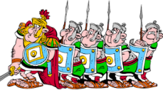  The Rotten Romans | Invaders: The Anglo-Saxons  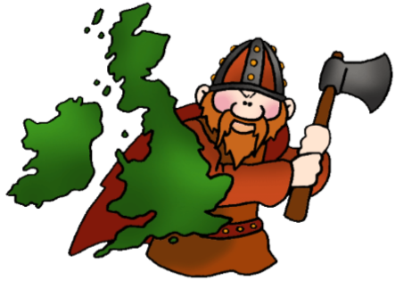 | Invaders: The Vikings!  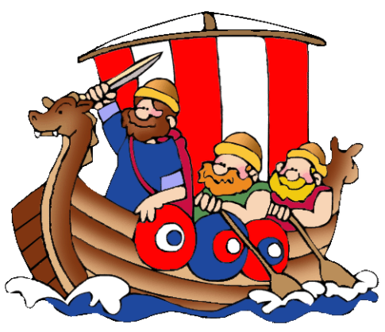 | Tropical Rainforest  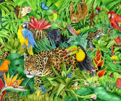 | My Green Country  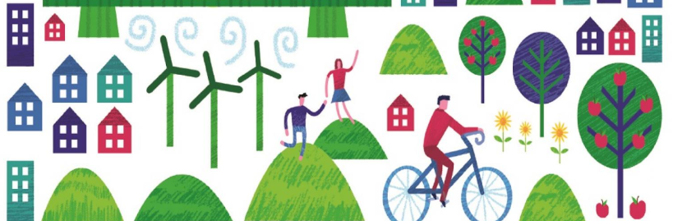 | Mighty Monarchs  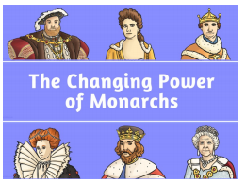
Wow starter  Visitor/trip | VR day |  | Jorvick Viking Centre or Viking Workshop | Tropical World | Fieldwork skills in the local area | Elizabethan banquet.
Reading into writing process | Weslandia and Julius Caesar (a Shakespeare story)  Fiction: historical fiction, play scripts, retelling, character description, book review, play scripts, a messing scene, speech writing.  Non-fiction: non-chronological report, persuasive leaflet, newspaper report. | Cineliteracy linked to The Dragon Slayer  Fiction: descriptive narrative for a scene, writing a sequel  Beowulf by Rob Lloyd Jones  Fiction: character and setting descriptions, using dialogue, letter writing (focus on showing, not telling), write own hero myth  Non-fiction- non-chronological reports on dragons | How to Train Your Dragon.  Fiction: written dialogue, Hiccup’s monologue, diary entry, character description, writing the next chapter in Hiccup’s POV.  Non-fiction: formal persuasive letter writing, fact files.  Poetry: Dragon shape poems | Cinnamon  Poetry- limericks  Non-fiction: adverts  Fiction: Diary entries, informal dialogue, and ‘stories in the style of'.  Jabberwocky  Poetry: Nonsense and narrative poetry and explanatory descriptions  The Girl who Fell From The Sky- Juliane Koepcke (Survivors)  Fiction: Short adventure story  Non-fiction: Newspaper report | The Abominables  Fiction: issue/dilemma narrative.  Non-fiction: autobiographies linked to journey through a mountain range.  Welcome to Nowhere by  Elizabeth Laird  Comparative setting descriptions (linking to drama and illustrative art), speech  Poetry: narrative poetry | My Friend Walter by Michael Morpurgo  Fiction: comic strip, short adventure story (linked to the power of invisibility), diary entry, descriptive character profiles, next chapter, predictions by writing the end of the story.  Non-fiction: newspaper article, auto biography (Sir Walter Raleigh), letter (replying to one in the story), descriptive poster for missing jewels
Cross-curricular writing | Fact files  Persuasive advertisement  Explanations  Storyboards | Diary entry  Fact files  A day in the life of… | Diary entry.  Letter writing.  Postcards. | Fairtrade posters and leaflets.  Writing linked to Earth Day | Explanation text.  Persuasive leaflet linked to renewable energy | Flip books/fact file.  Formal letter writing.  Persuasive leaflet  Descriptive Tudor menus
Guided reading book | Romans on the Rampage by Jeremy Strong. | Fergus Crane by Paul Stewart & Chris Riddell | Odd and the Frost Giants by Neil Gaiman and Chris Riddell | The Eye of the Wolf Paperback By Daniel Pennac | The Wind in the Willows by Kenneth Grahame | My Friend Walter by Michael Morpurgo
Class book | Roald Dahl- Charlie and the Chocolate Factory | Charlotte’s Web | How to Train Your Dragon | The Eye of the Wolf Paperback By Daniel Pennac | Welcome to Nowhere by  Elizabeth Laird | The Secret Diary of Thomas Snoop, Tudor Boy Spy by Philip Ardagh & Jamie Littler
Maths | Place value  Addition & Subtraction | Multiplication & Division  Fractions | Fractions  Decimals  Consolidation | Fractions  Time | Statistics  Properties of Shape  Position & Direction | Decimals  Money  Time
Cross-curricular maths | Roman numerals. | Time line- ordering numbers | Coordinates linked to map reading. | Temperature. | Measurement linked to DT. | Comparing what you could get for your money in Elizabethan times.
Science | Living things and their habitats  Recognise that living things can be grouped in a variety of ways.  Explore and use classification keys to help group, identify and name a variety of living things in their local and wider environment.  Recognise that environments can change and that this can sometimes pose dangers to living things. | Looking at states  Compare and group materials together, according to whether they are solids, liquids or gases.  Observe that some materials change state when they are heated or cooled, and measure or research the temperature at which this happens in degrees Celsius (°C).  Identify the part played by evaporation and condensation in the water cycle and associate the rate of evaporation with temperature. | What’s that sound?  Identify how sounds are made, associating some of them with something vibrating.  Recognise that vibrations from sounds travel through a medium to the ear.  Find patterns between the pitch of a sound and features of the object that produced it  Find patterns between the volume of a sound and the strength of the vibrations.  Recognise how sounds get fainter. | Teeth and eating  Describe the simple functions of the basic parts of the digestive system in humans  Identify the different types of teeth in humans and their simple functions.  Construct and interpret a variety of food chains, identifying producers, predators and prey. | Power it up!  Identify common appliances that run on electricity.  Construct a simple series electrical circuit, identifying and naming its basic parts.  Identify whether or not a lamp will light in a simple series circuit, based on whether or not the lamp is part of a complete loop with a battery.  Recognise that a switch opens and closes a circuit. | The Big Build
Geography | Locational knowledge  Name and locate countries and cities of the UK, geographical regions and identify their human & physical characteristics & land use; and understand how some of these aspects have changed over time.  Human & Physical geography  Describe and understand key aspects of human geography, including: types of settlement and land use  Geographical skills & fieldwork  Use maps and atlases locate countries and regions, describe features studied | Human & physical geography. Describe and understand key aspects of human geography, including: types of settlement and land use. How does this compare to the Romans?  Locational knowledge  Locate homelands of The Anglo-Saxons: Northern Germany, Denmark and The Netherlands, locating these European countries and their physical and human characteristics.  Name and locate countries and cities of the UK, geographical regions and identify their human & physical characteristics & land use; and understand how some of these aspects have changed over time.  Geographical skills & fieldwork  Use maps and atlases locate countries and regions, describe features studied | Geographical skills & fieldwork  Use four and six-figure grid references, symbols and key to build their knowledge of the UK and wider world.  Locational knowledge  Locate homelands of The Vikings: Norway, Sweden and Denmark, including their human characteristics.  Move on to locate Europe’s countries using maps (including the location of Russia), concentrating on their environmental regions, key physical and human characteristics, countries and major cities.  Place Knowledge  Understand geographical similarities and differences through the study of human and physical geography of a region of the UK and a region in a European country. | Locational knowledge  Identify the position and significance of latitude, longitude, Equator, Northern Hemisphere, Southern Hemisphere, the Tropics of Cancer and Capricorn the Prime/Greenwich Meridian and time zones (including day and night) in relation to Rainforests of the world.  Human & Physical geography  Describe and understand key aspects of physical geography, including: climate zones, biomes and vegetation belts.  Geographical skills & fieldwork  Use eight points of a compass, symbols and key to build their knowledge of the wider world. | Human & physical geography  Sustainability around the world.  Locating wind farms and explaining their location.  Locational knowledge  Locate counties and cities of the UK, geographical regions and their identifying human and physical characteristics, key topographical features (including hills, mountains, coasts and rivers), and land-use patterns linked to becoming ‘green’. Understand how some of these aspects have changed over time.  Geographical skills & fieldwork  Use fieldwork to observe, measure and record and present the sustainable physical features in the local area using a range of methods. Ordnance survey. | Locational knowledge  Locate parts of the country that where part of the Battle of Bosworth - the Battle of Bosworth – include cities and counties.  Locate parts of the world that formed the British Empire.  Human & physical geography  Discuss the trades of each country that formed part of the British Empire.
History | The Roman Empire and its impact on Britain. | Find out about Britain’s settlement by Anglo-Saxons, exploring the Anglos-Saxon invasion, settlements and kingdoms: place names and village life; Anglo-Saxon art and culture. | Find out about the Viking struggle for the kingdom of England to the time of Edward the Confessor. Explore Viking raids and invasion; resistance by Alfred the Great and Edward the Confessor’s death in 1066 |  | How has energy production changed over time?  Look at the use of canals and how they have changed e.g. in the past they were used to transport goods. Has this change made the country more eco-friendly? | Study the changing power of monarchs using case studies linked to the Tudors.  Change in social history- crime and punishment.
Art |  |  |  | Focus on Kandinsky  Use ‘circles’ art to create own Rainforest pieces e.g. 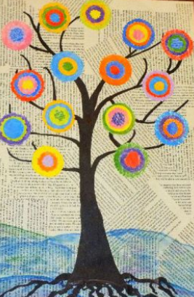
D & T | Research, plan, make and evaluate a Roman village/villa. | Research, plan, design and recreate Anglo-Saxon art (brooches) | Research, plan, design and make a Viking boat. | Make a digestive system. | Stem challenge: design and make a simple wind turbine. | Design, plan and sew a Tudor rose cushion.
Computing | Coding and e-safety | Spreadsheets and e-safety | Logo and e-safety | Animation and e-safety | Effective searching and e-safety | Hardware investigators and e-safety
P.E | Swimming  Y4 P.E scheme | Swimming  Y4 P.E scheme | Swimming  Y4 P.E scheme | Y4 P.E scheme | Swimming  Y4 P.E scheme | Y4 P.E scheme
Music | 70s pop - listen and appraise, play instruments with a song, improvise, compose and perform. | Develop playing skills through the glockenspiel- reading notes and scoring. | Song/rap about bullying - listen and appraise, play instruments with a song, improvise, compose and perform. | Soul/gospel - listen and appraise, play instruments with a song, improvise, compose and perform. | Explore songs with meaning (civil rights) - listen and appraise, play instruments with a song, improvise, compose and perform. | Consolidate learning that has occurred during the year. All the learning is focused around revisiting songs and musical activities, a context for the History of Music and the beginnings of the Language of Music.

