 | Autumn 1 | Autumn 2 | Spring 1 | Spring 2 | Summer 1 | Summer 2
Topic title | Raging Rivers  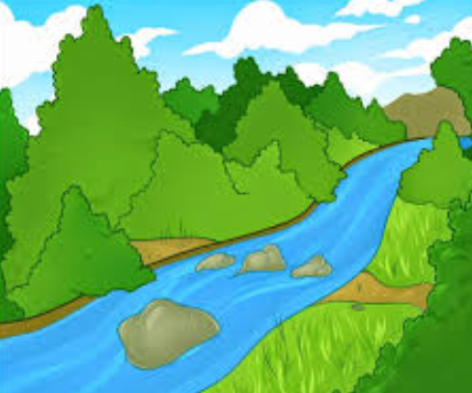 | Out of this World!  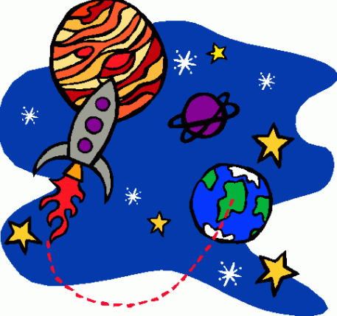 | 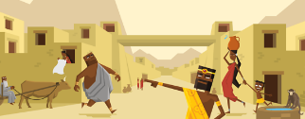  The Indus Valley Civilization | Ancient Greece  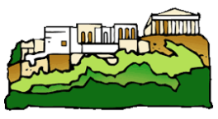 | Ain’t no Mountain High Enough!  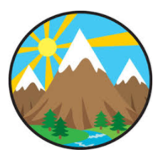 | The Great War  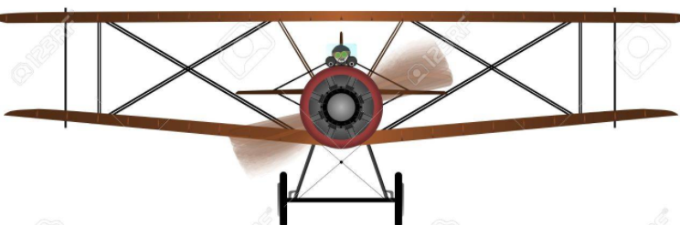
Wow starter  Visitor/trip | Prime VR  Yorkshire Water | Make a solar system ‘mobile’  World Museum |  | Ancient Greece drama workshop  Virtual Reality | Forest school- survival skills. | Build an Air Raid Shelter  Bankfield Museum
Reading into writing process | The Jungle Book  Fiction: narrative, descriptive scene, story writing, diary writing, internal monologue  Non-fiction: formal instructions  Hidden Figures (to celebrate Black History Month)  Character descriptions and formal persuasive letter. | Hidden Figures (continued)  Fiction: diary entry, memoir  Non-fiction: Non-chronological reports and informal letter  Robot Girl by Malorie Blackman  Discussion, debate, science fiction narrative  Cineliteracy linked to Wall.E  Fiction: sci-fi traditional tales.  Fiction: setting descriptions.  Non-fiction: formal letter writing- persuasion | The Tempest  Fiction: Setting description, character, descriptions and comparisons, diary entry, play scripts  Non-fiction: radio news reports and newspaper reports (lost at sea)  Poetry- linked to storms (cinquain) | D'Aulaires' Book of Greek Myths by Ingri d'Aulaire  Fiction: Myths and legends, character descriptions, play scripts, alternative ending  Non-fiction: balanced arguments (linked to the alternative ending), explanation text.  Falling Out of the Sky: Poems about Myths and Monsters  Poetry: narrative poetry | King of the Cloud Forests  by Michael Morpurgo  Fiction: play script (Jake’s first day with the yetis), detailed description when two characters meet, write a chapter from a different POV, adventure story  Non-fiction: letter writing  Poetry: Poems linked to themes in the story  The Mountaineer who overcame an avalanche- Colby Coombs (Survivors)  Fiction: Short adventure story  Non-fiction: Newspaper report | Armistice Runner (Conkers) by Tom Palmer  Fiction: Flashback stories, diary writing, chapter from another POV (e.g. first person), using dialogue effectively, writing a missing chapter  Non-fiction: Explanation texts linked to war
Cross-curricular writing | Water cycle stories and songs.  Explanation texts. | ‘Holiday brochures’ for each planet.  All about the ISS. | Leaflet.  Letter writing.  Diary entries. | Explanation texts.  Inside an Ancient Greek village…  Ancient Greek menus | Persuasive leaflets.  Information about habitats.  How to survive being stranded on a mountain. | News report  A day in the life of…
Guided reading book | Journey to the River Sea by Eva Ibbotson | The Secret of Platform 13 by Eva Ibbotson | The Explorer Paperback by Katherine Rundell | The Girl of Ink & Stars by Kiran Millwood Hargarve | Boy In The Back of tThe Class by Onjali Q. Raúf | The Garden of Lost Secrets by A.M Howell
Class book | Journey to the River Sea by Eva Ibbotson | The Secret of Platform 13 by Eva Ibbotson | The Explorer Paperback by Katherine Rundell | The Girl of Ink & Stars by Kiran Millwood Hargarve | Boy In The Back of tThe Class by Onjali Q. Raúf | The Garden of Lost Secrets by A.M Howell
Maths | Place Value  Addition & Subtraction  Statistics | Position & Direction  Converting units of measure  Volume | Multiplication & Division  Perimeter & Area  Consolidation | Decimals  Properties of Shape | Fractions  Decimals & Percentages  Consolidation | Length & Perimeter  Multiplication & Division  Consolidation
Science | Growing up and growing old  Describe the changes as humans develop to old age.  Indicate stages in the growth and development of humans.  Learn about the changes experiences in puberty. | Out of this world!  Describe the movement of the Earth and other planets relative to the sun in the solar system.  Describe the movement of the moon relative to the Earth.  Describe the sun, Earth and moon as approximately spherical bodies.  Use the idea of the Earth’s rotation to explain day and night. | Getting a reaction  Demonstrate that dissolving, mixing and changes of state are reversible changes (make potions)  Explain that some changes result in the formation of new materials, and that this kind of change is not usually reversible.  Know that some materials will dissolve in liquid to form a solution, and describe how to recover a substance from a solution.  Use knowledge of solids, liquids and gases to decide how mixtures might be separated. | Let’s get moving (Forces)  Describe the movement of the Earth and other planets relative to the sun in the solar system.  Describe the movement of the moon relative to the Earth.  Explain that unsupported objects fall towards the Earth because of the force of gravity acting between the Earth and the falling object.  Identify the effects of air resistance, water resistance and friction, that act between moving surfaces.  Recognise that some mechanisms including levers, pulleys and gears allow a smaller force to have a greater effect. | Living things in their habitats  Describe the differences in the life cycles of a mammal, an amphibian, an insect and a bird.  Describe the life process of reproduction in some plants and animals.  Link the above to eco-systems and habitats found on mountains. | Material world  Compare and group materials together, according to whether they are solids, liquids or gases.  Observe that some materials change state when they are heated or cooled, and measure or research the temperature at which this happens in degrees Celsius.  Identify the part played by evaporation and condensation in the water cycle and associate the rate of evaporation with temperature
Geography | Human & physical geography. Describe and understand key aspects of rivers and the water cycle.  Describe and understand key aspects of human geography, including: land use, linking specially to how rivers have changed over time and how human activity affects rivers.  Locational knowledge.  Locate rivers on maps, globes and atlases.  Explore climate zones of different rivers.  Geographical skills & fieldwork  To be able to locate rivers using an atlas and world map. | Locational knowledge  Identify the position and significance of the Prime/Greenwich Meridian and time zones (including day and night)- linking to the significance of latitude and longitude.  Geographical skills & fieldwork  Locate the world’s countries, using maps to focus on Europe, Including the location of Russia) and North and South America – link to research on space travel.  Use digital/computer mapping. | Locational knowledge  Identify land-use patterns and how these have changed over time.  Human & Physical geography  Describe and understand key aspects of physical geography, including: climate zones and vegetation belts.  Describe and understand key aspects of human geography, including: economic activity including trade links, and the distribution of natural resources including energy, food, minerals and water.  Use maps and atlases to locate countries studied. | Place Knowledge  Understand geographical similarities and differences through the study of human and physical geography of a region of the UK and a region in a European country.  Human & Physical Geography  Describe and understand key aspects of human geography, including: types of settlement and land use, economic activity including trade links (including what the main exports were in Ancient Greece).  Geographical skills & fieldwork  Use maps and atlases to locate countries and describe features studied. | Human & physical geography  Describe and understand key aspects of mountains.  Describe and understand key aspects of physical geography, including mountains and the vegetation zones found in mountain ranges.  Locational Knowledge  Name and locate counties and cities of the UK, and their identifying key topographical features including hills, mountains. Discuss the differences between the two.  Geographical skills & fieldwork  Use ordnance survey maps along with symbols and keys to locate mountain ranges. Use maps, atlases, globes and digital/computer mapping to locate countries and describe features (mountain ranges) studied.  Use fieldwork to observe, measure and record and present the human and physical features in the local area using a range of methods, including plans – link to Y5 big walk. | Locational knowledge  Locate countries involved in WWI.  Geographical skills & fieldwork  Use maps, atlases and digital devices to describe and locate places studied.  Human & physical geography.  Describe and understand key aspects of human geography, including distribution of natural resources.
History | To identify how rivers have changed over time (look at River Don and River Yamuna). | To identify significant turning points in the history of space – for both Britain and the world.  Use appropriate historical vocabulary to communicate e.g. dates, time periods, era, change, chronology | An overview of where and when the first civilizations appeared and a depth study of The Indus Valley. Compare to previously taught early civilizations. | Recognise the achievements of the earliest civilizations – Ancient Greece.  Study Greek life and achievements and their influence on the western world. |  | Significant figures in WWI.  How the war affected daily life in Britain.  How life changed for children.  How the war ended and the treaty of Versailles.
Art | Research famous artists and create river drawings using acrylic paint |  | Sketching Indus art and craft. |  | Study the work on Van Gogh and discuss how his work can be adapted to create mountain images.
D & T |  | Research, plan & make a ‘space vehicle’ that moves. |  | Research, plan and make a Greek pottery vase- clay. |  | Research, design and make an air raid shelter
Computing | Coding and e-safety | Spreadsheets and e-safety | Databases and e-safety | Game creator and e-safety | 3D modelling and e-safety | Concept maps and e-safety
P.E | Y5 P.E scheme | Y5 P.E scheme | Y5 P.E scheme | Y5 P.E scheme | Y5 P.E scheme | Y5 P.E scheme
Music | Rock - Explore the dimensions of music and play instrumentals to part of a song. | Jazz part 1 - Revisit songs and musical activities. Explore the history of music and the beginnings of the language of music. | Pop - Listen and appraise and use instruments to play as part of an ensemble. | Hip Hop - Listen and appraise (Motown), play as part of an ensemble, read notation. | Motown - Singing, performing and playing instruments using notation. | Western classical music - Learn about interrelated dimensions of music through playing instruments and improvising.

