 | Autumn 1 | Autumn 2 | Spring 1 | Spring 2 | Summer 1 | Summer 2
Topic title | Hola Mexico  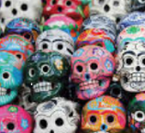 | To Be or Not to Be | 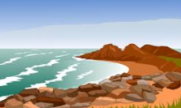  Coast to Coast | The Blitz  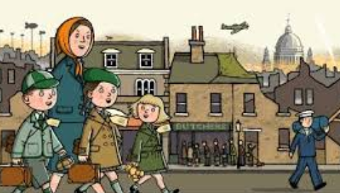 | Darwin’s Delights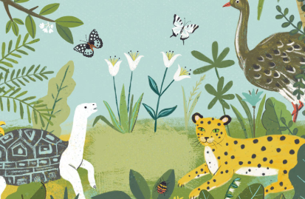 | Extreme Environments!  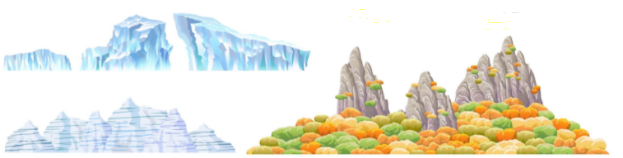
Wow starter  Visitor/trip | Virtual reality: Trip to Chichen Itza  Residential | Drama- performing parts of Macbeth  Trip to Ilkley Moor | Make a lighthouse with a working bulb | Forest School- making a rationed meal.  Eden Camp | Making fossils | Science investigations linked to adaptation ‘blubber glove’.
Reading into writing process | Rain Player  Fiction: missing scene, diary, description, posters.  Non-fiction: newspaper, balanced argument, analytical essay, instructions.  The Maya History in infographics  Explanation texts  Life Stories: Martin Luther King Jr  Newspaper reports, poetry writing, biographies | Macbeth  Fiction: spooky story & description.  Non-fiction: biography linked to character, formal letter writing, explanation text  A Christmas Carol: descriptive writing, diary entries, narrative, persuasive speech | The Wreck of the Zanzibar Fiction: description of the arrival of the storm, write a missing chapter (adventure)  Non-fiction: live news report (linked to the rescue), letter writing (from Billy to family)  Poetry: narrative poetry linked to the dying island  Picture book- Way Home  Fiction: setting description & short flashback story  Non-fiction: Homelessness explanation text | Goodnight Mister Tom  Fiction: Comparative memoir between an evacuee child and refugee child, missing chapter/scene, alternative POV  My Secret War Diary  Fiction: diary entries, short narrative linked to the London blitz  Non-fiction Newspaper report, balanced argument, letter writing.  Persuasive speech (World Book Day) | The Hobbit  Fiction: quest fiction (using dialogue effectively) & character/setting description.  Non-fiction: persuasive leaflet  The Unforgotten Coat  Fiction: Narrative (issues and dilemmas), diary entries, dialogue,  Non-fiction: non-chronological report, journals (recounts) | Survivors: The student who was sucked under by quicksand  The Canyoneer Who Cut Off His Own Arm  ‘The Man Who Walked Between Two Bridges’: memoirs and fact files  Queen of the Falls  Fiction: adventure story.  Non-fiction: biographies.
Cross-curricular writing | Tourist leaflets.  Explanation texts.  Descriptive writing about festivals  Folk tales linked to The Chocolate Tree. | Recount linked to trip.  Own short play script.  Explanation linked to Science.  Fact files.  Persuasive leaflet- theatres.  Diary entry- Shakespeare. | Emails/blogs/informal letter.  Information  Diary entry from residential (style of Diary of a Wimpy Kid). | Diary writing.  Formal letters.  Biographies.  Explanation texts.  Persuasive- Women at War.  Stories linked to art. | Recount linked to trip.  Explanation texts.  Balanced argument.  Journey of a fossil stories. | Science- fact files.  Persuasive leaflets.  Science investigations.
Guided reading book | Clockwork or All Wound up by Philip Pullman | Skellig by David Almond | A Beautiful Lie by Irfan Master | The Emergency Zoo by Miriam Halahmy | The Unforgotten Coat  by Frank Cottrell Boyce | Stormbreaker by Anthony Horowitz
Class book | Clockwork or All Wound up by Philip Pullman | Skellig by David Almond | A Beautiful Lie by Irfan Master | The Emergency Zoo by Miriam Halahmy | Wonder by Raquel J. Palacio | Stormbreaker by Anthony Horowitz
Maths | Place Value  Addition, Subtraction, Multiplication & Division | Decimals  Percentages  Algebra | Converting units  Perimeter, Area & Volume  Ratio  Consolidation | Fractions  Position & direction  Consolidation | Properties of shape  Problem solving  Statistics | Consolidation  Investigations
Cross-curricular maths | Measuring heart rate & presenting data. | Reading coordinates as part of map work. | Data- different types of graphs to record statistics. | Time line- ordering events & discussing impact. |  | Time & measure for cooking.
Science | Animals including humans  Identify &name the main parts of the human circulatory system, &describe the functions of the heart, blood vessels &blood.  Recognise the impact of diet, exercise, drugs &lifestyle on the way their bodies function.  Describe the ways in which nutrients &water are transported within animals, including humans. | Electricity  Associate the brightness of a lamp or the volume of a buzzer with the number &voltage of cells used in the circuit.  Compare &give reasons for variations in how components function, including the brightness of bulbs, the loudness of buzzers &the on/off position of switches.  Use recognised symbols when representing a simple circuit in a diagram | Light  Recognise that light appears to travel in straight lines.  Use the idea that light travels in straight lines to explain that objects are seen because they give out or reflect light into the  eye. | Light (b)  Explain that we see things because light travels from light sources to our eyes or from light sources to objects & then to our eyes.  Use the idea that light travels in straight lines to explain why shadows have the same shape as the objects that cast them. | Evolution & inheritance  Recognise that living things have changed over time &that fossils provide information about living things that inhabited the Earth millions of years ago.  Recognise that living things produce offspring of the same kind, but normally offspring vary &are not identical to their parents.  Identify how animals &plants are adapted to suit their environment in different ways &that adaptation may lead to evolution. | Living things & their habitats  Describe how living things are classified into broad groups according to common observable characteristics &based on similarities &differences, including micro-organisms, plants & animals.  Give reasons for classifying plants & animals based on specific characteristics.
Geography | Locational knowledge & place knowledge.  Compare Mexico with the England including climate, population and landscapes. Identify the climates of The Tropic of Cancer. Identify the position of the equator  Place Knowledge  Understand geographical similarities and differences through the study of human and physical geography of a region of the UK and a region within South America.  Human & Physical Geography  Describe and understand key aspects of physical geography, including: climate zones, rivers, mountains, and other landscapes. | Locational knowledge  Name and locate counties and cities of the United Kingdom some countries and capital cities of Europe.  Geographical skills & fieldwork  Use fieldwork to observe, measure, record and present the human and physical features using sketch maps as a method (Y6 big walk to Ilkley Moor) | Human & Physical Geography  Describe and understand human geography, including: types of settlement and land use, economic activity including trade links, and the distribution of natural resources including energy, food, minerals and water discussing key areas of the British coast lines that support economic trade.  Describe and understand key aspects of the water cycle.  Geographical skills & fieldwork  Use ordnance survey maps to identify a range of physical and human features which surround the coastal landscape.  Locational Knowledge  Name and locate UK geographical regions and their identifying human and physical characteristics, key topographical features (including coasts), and land-use patterns; and understand how some of these aspects have changed over time.  Geographical skills & fieldwork  Use Ordnance survey maps | Locational knowledge  Locate the world’s countries, using maps to focus on Europe (including the location of Russia), concentrating on their environmental regions, key physical and human characteristics, countries, and major cities – link to allies and axis  Human & Physical geography  Describe and understand key aspects of human geography, such as economic activity including trade links, and the distribution of natural resources including energy, food, minerals and water during WW2.  . | Geographical skills & fieldwork  Use a range of maps, globes & atlases to describe the features of a place.  Human & Physical Geography  Describe and understand key aspects of physical geography, including: biomes, vegetation belts and climate zone linked to Galapagos islands. | Locational knowledge & human & physical geography  Identify the position and significance of the Arctic and Antarctic Circle, of latitude, longitude, the Prime/Greenwich Meridian and time zones.  Describe and understand key aspects of physical geography, including: climate zones, biomes and vegetation belts..  Geographical skills & fieldwork  Use a range of maps, globes & atlases to describe the features of a place.  Orienteering skills linked to using eight points on a compass.
History | Ancient Maya Civilisation. Compare ancient beliefs with those of today, explore & discover what life was like of a Mayan & learn about the significant historical buildings & sculptures of these times. | Identify how people’s lives have shaped this nation (Shakespeare and Queen Elizabeth I).  Study an aspect of British history that extends pupils’ chronological knowledge beyond 1066 by identifying the changing power of monarchs.  Recognise The Golden Age as a significant turning point in British history.  Use range of sources of information to gain historical perspective. | How have coastlines changed? Why have they changed?  Historical events such as 2011 tsunami. | Recognise a significant turning point in Britain- WWII. |  | Study an aspect of British history that extends pupils’ chronological knowledge beyond 1066: explorers of the 19th century.
Art |  |  | Coastal sketches- look at Claude Monet | Henry Moore study- use charcoal & sketching.  Propaganda posters.
D & T | Mexican ’Day of the Dead’/’Dia de los Muertos’. Design, make & evaluate a 3D skull. | Replica model of The Globe Theatre |  |  | Fossil making. | Research, design and make an energy bar that is high in energy.
Computing | Coding and e-safety | Spreadsheets and e-safety | Blogging and e-safety | Text adventures and e-safety | Networks and e-safety | Quizzing and e-safety
P.E | Y6 P.E scheme but with a link to Mexican dances & festivals. | Y6 P.E scheme | Y6 P.E scheme | Y6 P.E scheme | Y6 P.E scheme | Y6 P.E scheme
Music | Pop/motown- Listen and appraise, play instruments, improvise and perform. | Jazz part 2 - Listen and appraise, play instruments, improvise and perform. | Western classical music, Gospel, Bhangra - Listen and appraise, perform and play instruments reading notations. | Focus TBC - Singing, composing, playing instruments and playing as part of an ensemble. | The music of Carole King-  Singing, composing, playing instruments and playing as part of an ensemble. | Focus on revisiting songs and musical activities, a context for the History of Music and the beginnings of the Language of Music.

