W/C 30th March | EYFS & KS1 Group 1 | EYFS & KS1 Group 2 | KS2 Group 3 | KS2 Group 4 | KS2 Group 5
Monday  Children will be taught how to use different textiles to create and design their own character puppet | Textile workshop | Textile workshop | Textile workshop | Textile workshop | Textile workshop
Tuesday  Children will cook a main course in the food technology classroom to take home for their family’s evening meal | Cooking workshop | Cooking workshop | Cooking workshop | Cooking workshop | Cooking workshop
Wednesday  Children will have a golf lesson by a specialist PE teacher on the school’s sports field | Golf lesson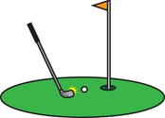 | Golf lesson  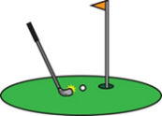 | Golf lesson  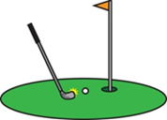 | Golf lesson | Golf lesson
Thursday  Children will make a space rocket taught by a specialist science teacher in the lab | Science workshop | Science workshop | Science workshop | Science workshop | Science workshop
Friday  Children will be taught basketball skills by a specialist PE teacher in the sports hall | Basketball skills | Basketball skills | Basketball skills | Basketball skills | Basketball skills

Please note: group size approximately 4 pupils

